Project Design Phase-II Customer Journey

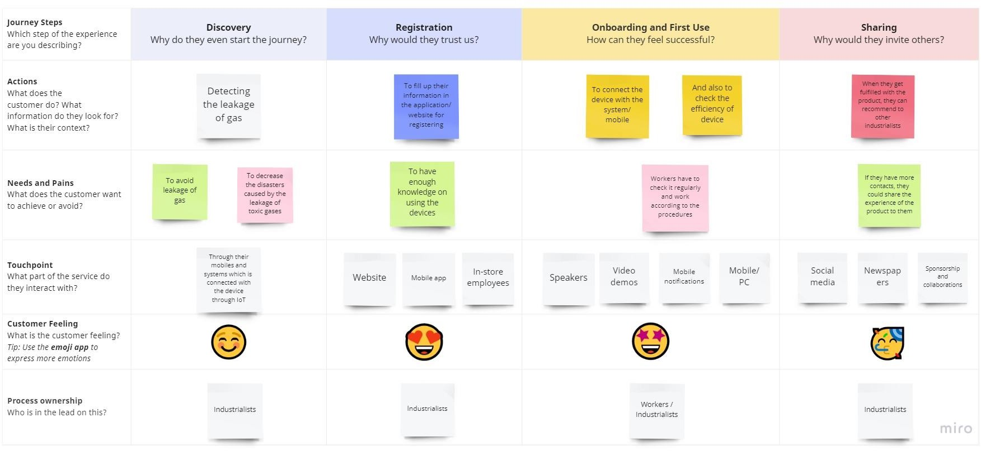

|  |  |
| --- | --- |
| Date | 10 October 2022 |
| Team ID | PNT2022TMID42967 |
| Project Name | Gas leakage monitoring and alerting system for industries |